SQL Hints

sp_who2
sp_monitor
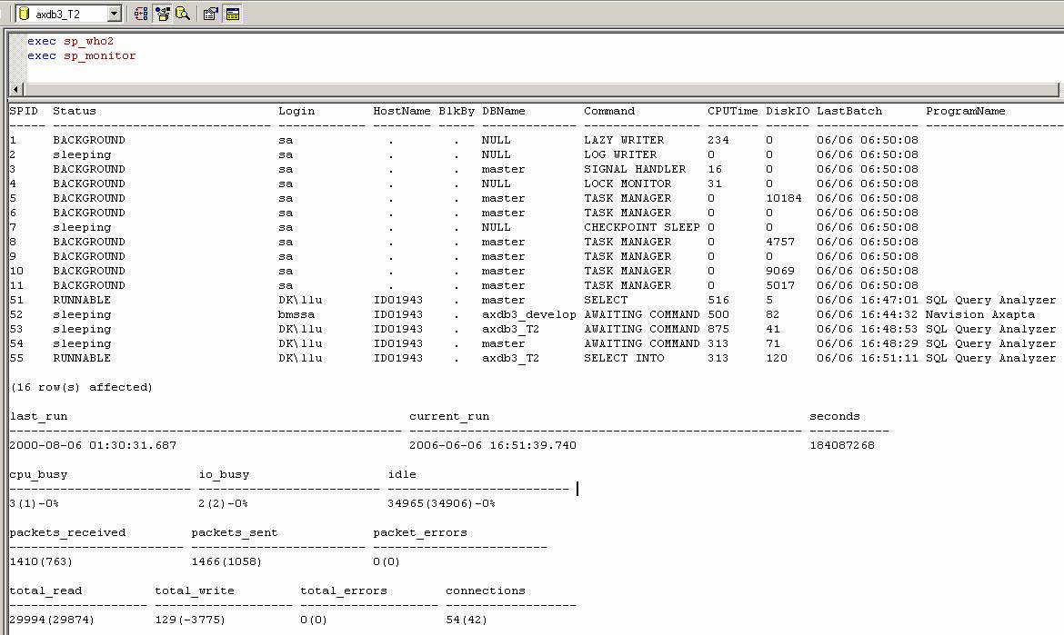

DBCC SHOWCONTIG: Displays fragmentation information for the data and indexes of the specified table
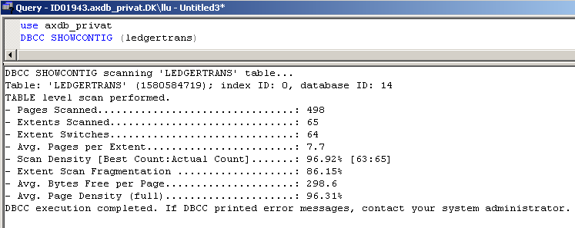

DBCC INDEXDEFRAG
Før Efter
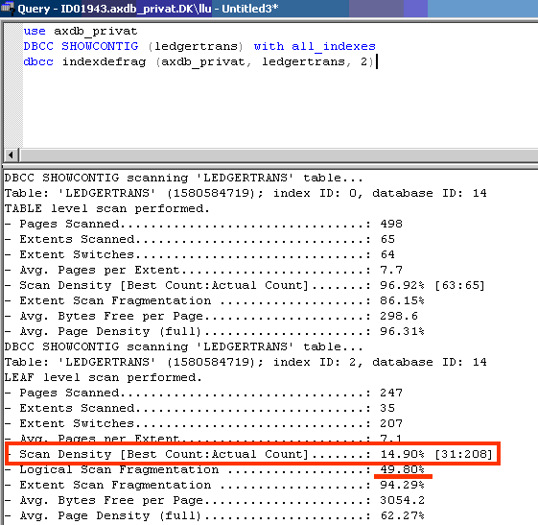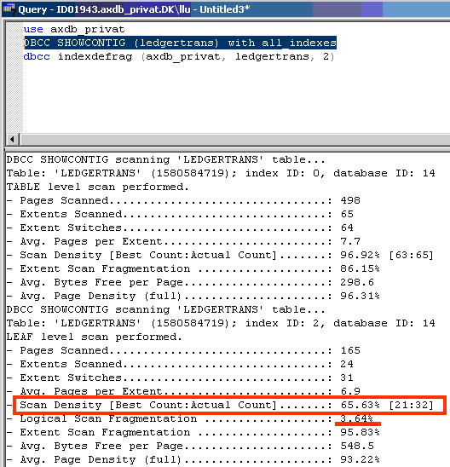

PRINT '3) HERE IS MM-DD-YYYY FORMAT ==>' +
CONVERT(CHAR(10),GETDATE(),110)
DROP TABLE X
GO
SET NOCOUNT ON
CREATE TABLE X(line INTEGER, D DATETIME)
INSERT INTO X VALUES (1,'19561030')
INSERT INTO X VALUES (2,'561030')
INSERT INTO X VALUES (3,'10/30/1956')
INSERT INTO X VALUES (4,'10/30/56')
INSERT INTO X VALUES (5,'30 OCT 1956')
INSERT INTO X VALUES (6,'30 OCT 56')
INSERT INTO X VALUES (7,'OCT 30 1956')
INSERT INTO X VALUES (8,'OCT 30, 1956')
INSERT INTO X VALUES (9,'OCT 30, 56')
INSERT INTO X VALUES (10,'OCTOBER 30, 1956')
SELECT * FROM X
select year(d) from x
select month(d) from x
select day(d) from x

http://www.databasejournal.com/features/mssql/article.php/3654176
http://www.databasejournal.com/features/article.php/3593466

SQLCMD -S -U -P -Q
SQLCMD -SHOME\SQLEXPRESS -Usa -P******
1> select @@servername
2> Select @@version
3> go
HOME\SQLEXPRESS
1> quit

Brug af Trusted Connections og direkte SQL
sqlcmd -S0255-PCS -E -Q"select * from ax30_procon.dbo.tr_custpricetable"

Brug af inputfil
sqlcmd -S0255-PCS -E -i c:\test.sql

IN funktionen:
Update Emp set [Marital Status]='S' where id in (1,5,8)
CASE funktionen
Select [id],[Full Name] = case Gender
when 'm' then 'Mr. '+[First name]+ ' '+[Last name]
when 'f' then 'Mz. '+[First name]+ ' '+[Last name]
else [First name]+ ' '+[Last name]
end
from Emp

Datefunctions
Datepart
SELECT
CONVERT(char(10), MyDateTime, 101) AS [Date],
CONVERT(varchar(2),
CASE
WHEN DATEPART([hour], MyDateTime) > 12 THEN CONVERT(varchar(2), (DATEPART([hour], MyDateTime) - 12))
WHEN DATEPART([hour], MyDateTime) = 0 THEN '12'
ELSE CONVERT(varchar(2), DATEPART([hour], MyDateTime))
END
) + ':' +
CONVERT(char(2), SUBSTRING(CONVERT(char(5), MyDateTime, 108), 4, 2)) + ' ' +
CONVERT(varchar(2),
CASE
WHEN DATEPART([hour], MyDateTime) > 12 THEN 'PM'
ELSE 'AM'
END
) AS [Time]
FROM
MyTable
Date Convert types
PRINT '1) HERE IS MON DD YYYY HH:MIAM (OR PM) FORMAT ==>' + CONVERT(CHAR(19),GETDATE())
PRINT '2) HERE IS MM-DD-YY FORMAT ==>' + CONVERT(CHAR(8),GETDATE(),10)
PRINT '3) HERE IS MM-DD-YYYY FORMAT ==>' + CONVERT(CHAR(10),GETDATE(),110)
PRINT '4) HERE IS DD MON YYYY FORMAT ==>' + CONVERT(CHAR(11),GETDATE(),106)
PRINT '5) HERE IS DD MON YY FORMAT ==>' + CONVERT(CHAR(9),GETDATE(),6)
PRINT '6) HERE IS DD MON YYYY HH:MM:SS:MMM(24H) FORMAT ==>' + CONVERT(CHAR(24),GETDATE(),113)
Here is the output from the above script:
1) HERE IS MON DD YYYY HH:MIAM (OR PM) FORMAT ==>Feb 5 2003 5:54AM
2) HERE IS MM-DD-YY FORMAT ==>02-05-03
3) HERE IS MM-DD-YYYY FORMAT ==>02-05-2003
4) HERE IS DD MON YYYY FORMAT ==>05 Feb 2003
5) HERE IS DD MON YY FORMAT ==>05 Feb 03
6) HERE IS DD MON YYYY HH:MM:SS:MMM(24H) FORMAT ==>05 Feb 2003 05:54:39:567

dbcc freeproccache
DBCC FREEPROCCACHE;
DBCC FREESESSIONCACHE

http://www.ss64.com/sql/

Aggregate - CREATE AGGREGATE
- DROP AGGREGATE
Application Role - CREATE APPLICATION ROLE
- ALTER APPLICATION ROLE
- DROP APPLICATION ROLE
Assembly - CREATE ASSEMBLY
- ALTER ASSEMBLY
- DROP ASSEMBLY
ALTER AUTHORIZATION

BACKUP
BACKUP CERTIFICATE
BEGIN [DIALOG [CONVERSATION]]

Certificate - ALTER CERTIFICATE
- CREATE CERTIFICATE
- DROP CERTIFICATE
CHECKPOINT
COMMIT
Contract - CREATE CONTRACT
- DROP CONTRACT
Credential - CREATE CREDENTIAL
- ALTER CREDENTIAL
- DROP CREDENTIAL

Database - CREATE DATABASE
- ALTER DATABASE
- DROP DATABASE
DBCC CHECKALLOC - Check consistency of disk allocation.
DBCC CHECKCATALOG - Check catalog consistency
DBCC CHECKCONSTRAINTS - Check integrity of table constraints.
DBCC CHECKDB - Check allocation, and integrity of all objects.
DBCC CHECKFILEGROUP - Check all tables and indexed views in a filegroup.
DBCC CHECKIDENT - Check identity value for a table.
DBCC CHECKTABLE - Check integrity of a table or indexed view.
DBCC CLEANTABLE - Reclaim space from dropped variable-length columns.
DBCC dllname - Unload a DLL from memory.
DBCC DROPCLEANBUFFERS - Remove all clean buffers from the buffer pool.
DBCC FREE... CACHE - Remove items from cache.
DBCC HELP - Help for DBCC commands.
DBCC INPUTBUFFER - Display last statement sent from a client to a database instance.
DBCC OPENTRAN - Display information about recent transactions.
DBCC OUTPUTBUFFER - Display last statement sent from a client to a database instance.
DBCC PROCCACHE - Display information about the procedure cache
DBCC SHOW_STATISTICS - Display the current distribution statistics
DBCC SHRINKDATABASE - Shrink the size of the database data and log files.
DBCC SHRINKFILE - Shrink or empty a database data or log file.
DBCC SQLPERF - Display transaction-log space statistics. Reset wait and latch statistics.
DBCC TRACE... - Enable or Disable trace flags
DBCC UPDATEUSAGE - Report and correct page and row count inaccuracies in catalog views
DBCC USEROPTIONS - Return the SET options currently active
DBCC deprecated commands
DECLARE
Default - CREATE DEFAULT
- DROP DEFAULT
DELETE
DENY - DENY Object permissions
- DENY User/Role permissions
Endpoint - CREATE ENDPOINT
- ALTER ENDPOINT
- DROP ENDPOINT
Event - CREATE EVENT NOTIFICATION
- DROP EVENT NOTIFICATION
EXECUTE
EXECUTE AS

Fulltext Catalog - CREATE FULLTEXT CATALOG
- ALTER FULLTEXT CATALOG
- DROP FULLTEXT CATALOG
Fulltext Index - CREATE FULLTEXT INDEX
- ALTER FULLTEXT INDEX
- DROP FULLTEXT INDEX
Function - CREATE FUNCTION
- ALTER FUNCTION
- DROP FUNCTION

GO
GRANT - GRANT Object permissions
- GRANT User/Role permissions

Index - CREATE INDEX
- ALTER INDEX
- DROP INDEX
INSERT
iSQL -U user -P password -i script.sql -o logfile.log

Key - CREATE ASYMMETRIC KEY
- ALTER ASYMMETRIC KEY
- DROP ASYMMETRIC KEY
- CREATE SYMMETRIC KEY
- OPEN SYMMETRIC KEY
- CLOSE SYMMETRIC KEY
- ALTER SYMMETRIC KEY
- DROP SYMMETRIC KEY
KILL
KILL QUERY NOTIFICATION
KILL STATS JOB

Login - CREATE LOGIN
- ALTER LOGIN
- DROP LOGIN

Master Key - CREATE MASTER KEY
- ALTER MASTER KEY
- BACKUP MASTER KEY
- DROP MASTER KEY
- RESTORE MASTER KEY
- ALTER SERVICE MASTER KEY
- BACKUP SERVICE MASTER KEY
- RESTORE SERVICE MASTER KEY
Message Type - CREATE MESSAGE TYPE
- ALTER MESSAGE TYPE
- DROP MESSAGE TYPE

Partition Function - CREATE PARTITION FUNCTION
- ALTER PARTITION FUNCTION
- DROP PARTITION FUNCTION
Partition Scheme - CREATE PARTITION SCHEME
- ALTER PARTITION SCHEME
- DROP PARTITION SCHEME
Procedure - CREATE PROCEDURE
- ALTER PROCEDURE
- DROP PROCEDURE

Queue - CREATE QUEUE
- ALTER QUEUE
- DROP QUEUE

Remote Service Binding - CREATE REMOTE SERVICE BINDING
- ALTER REMOTE SERVICE BINDING
- DROP REMOTE SERVICE BINDING

RESTORE - RESTORE DATABASE Complete
RESTORE DATABASE Partial
RESTORE DATABASE Files
RESTORE LOGS
RESTORE DATABASE_SNAPSHOT
RESTORE FILELISTONLY - List database and log files
RESTORE HEADERONLY - List backup header info
RESTORE LABELONLY - Media info
RESTORE REWINDONLY - Rewind and close tape device
RESTORE VERIFYONLY
REVERT
REVOKE - REVOKE Object permissions
- REVOKE User/Role permissions
Role - CREATE ROLE
- ALTER ROLE
- DROP ROLE
ROLLBACK
Route - CREATE ROUTE
- ALTER ROUTE
- DROP ROUTE

Schema - CREATE SCHEMA
- ALTER SCHEMA
- DROP SCHEMA
SELECT
SEND
SERVERPROPERTY
Service - CREATE SERVICE
- ALTER SERVICE
- DROP SERVICE
SESSION_USER
SESSIONPROPERTY
SET @local_variable
SET
SHUTDOWN
Signature - ADD SIGNATURE
- DROP SIGNATURE
Statistics - CREATE STATISTICS
- UPDATE STATISTICS
- DROP STATISTICS

Synonym - CREATE SYNONYM
- DROP SYNONYM

Table - CREATE TABLE
- ALTER TABLE
- DROP TABLE
- TRUNCATE TABLE
Transaction - BEGIN DISTRIBUTED TRANSACTION
- BEGIN TRANSACTION
- COMMIT TRANSACTION
Trigger - CREATE TRIGGER
- ALTER TRIGGER
- ENABLE TRIGGER
- DISABLE TRIGGER
- DROP TRIGGER
Type - CREATE TYPE
- DROP TYPE

UNION
UPDATE
User - CREATE USER
- ALTER USER
- DROP USER
USE

View - CREATE VIEW
- ALTER VIEW
- DROP VIEW

XML Schema Collection - CREATE XML SCHEMA COLLECTION
- ALTER XML SCHEMA COLLECTION
- DROP XML SCHEMA COLLECTION

